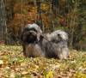 | Trial breeding with BISS RBIS GCH JiJo's & Shatara's High Voltage and  GCH CH Dearheart's Beseme American Sweetheart -  5 generation pedigree (100% complete)
LGD=87.5% (32/28)
COI = 10.16%
AM CAN INTL MEX CH Starkette Pride of Wincroft ROMX: 3.90625%
Ch Los Perritos Wee Pantaloons ROMX: 2.34375%
CH Los Perritos Wee Pantaloons ROMX: 2.34375%
CH FORGATE'S PANDEMONIUM OF LP: 1.5625%
BISS RBISGCH JiJo's & Shatara's High Voltage | CHMYSTIC JI JO'S DRAGON HEART | CH LOS PERRITOS FAMILY TRADITION | CH LOS PERRITOS OVERLOOK ICEMAN | CH FORGATE'S PANDEMONIUM OF LP
 |  |  |  | CH LOS PERROS LIL ORPHAN ANNIE
 |  |  | CH MISCHIEF'S NAUGHTY BUT NICE | Ch Los Perritos Wee PantaloonsROMX
 |  |  |  | CH LOS PERROS LIMA BEANIE BABY
 |  | CH JI JO'S SHAME ON THE MOON AT MYSTIC | CH JI JO'S AMIGO OF LOS PERRITOS | Ch Los Perritos Wee PantaloonsROMX
 |  |  |  | CH LOS PERRITOS CADILLAC SUNRISE
 |  |  | CH FORGATE'S PEBBLES OF LP | Ch Los Perritos Wee PantaloonsROMX
 |  |  |  | Ch Los Perritos Irmas Gypsy Toy
 | JI JO'S BLOW ME A KISS | CH JI JO'S SON OF PAN | CH LOS PERRITO'S WEE PANTALOONS | CH LOS PERRITOS LUGI
 |  |  |  | US CHBorgia's Evita Of Romanijo's JoyROMX
 |  |  | SHELLEY'S SALT AND PEPPER | CH FORGATE'S PANDEMONIUM OF LP
 |  |  |  | SHELLY'S HOLLY NOEL
 |  | CH JI JO'S KISS ME KATE | CH STARKETTE PRIDE OF WINCROFT | CH VOILA PRIME TIME
 |  |  |  | CH STARKETTE COOKIES AND CREAM
 |  |  | CH CODICOR'S LOOK AT ME CROFTONCD | CH KOLMAR'S CARIBBEAN BREEZE
 |  |  |  | CH BACARDI'S WAIT FOR ME CROFTON
GCH CHDearheart's Beseme American Sweetheart | GCHWINCROFT'S AMERICAN HEROCGC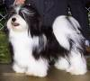 | AM CAN INTL MEX CHStarkette Pride of WincroftROMX | AM CHVoila Prime TimeROM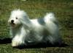 | SUCHInvibe's Whiskey Pete's In Nevada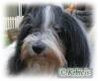
 |  |  |  | CHA Maiden Effort's Wish Me Luck
 |  |  | CHStarkette Cookies And CreamROM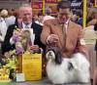 | AM CHKatrina's Charmer Of ManfredROMX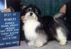
 |  |  |  | HCA CHStarkette Cabbage Patch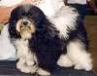
 |  | CHWINCROFT KNICK O'TIME BRYCECREEK | CHLos Perritos Wee PantaloonsROMX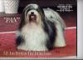 | CHLos Perritos LuigiROM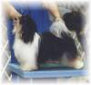
 |  |  |  | US CHBorgia's Evita Of Romanijo's JoyROMX
 |  |  | CHWincroft Sweet ChimayoROM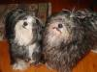 | AM CAN INTL MEX CHStarkette Pride of WincroftROMX
 |  |  |  | AM CH.Silverdale Star Of WincroftROM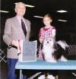
 | AKC CHBeseme's 2 Cute 4 Words@Dearheart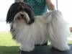 | AKC GCH UKC BISBeseme's Dancing With The Stars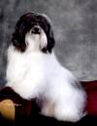 | CHLos Feliz Splash Of Mollimar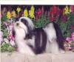 | CHLos Perritos Wee PantaloonsROMX
 |  |  |  | CHKolmar's MS QT PI Of Los Feliz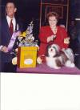
 |  |  | GCH CHBeseme's An Affair To Remember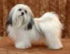 | CHShelley's Rickie Ricardo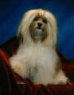
 |  |  |  | CHLiveoak's Southern CharmRN ROM
 |  | CH.SandCastle's Heart's DesireRN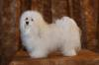 | AKC, UKC, INT CHShaggyluv's BlockbusterNA, NAJ, NJP, RN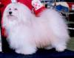 | AKC, ARBA CHShaggyluv's EnergizerNA, NAJ, OA, OAJ, RN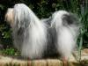
 |  |  |  | AKC, ARBA, HCA CHShaggyluv's Golden GirlNA, NAJ, OA, OAJ, RN, RA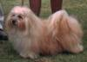
 |  |  | CHShelley's Havana Queen of HeartsROM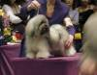 | CHAlderon's Shelley's Jamoacha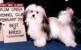
 |  |  |  | Destiny's Shelley's Cookies N Creme