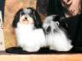
Trial breeding with GRCH Tigerlily Tamaran Smoke On The Water and
GCH UKC BIS Beseme's Any Dream Will Do -
5 generation pedigree (100% complete)
LGD=81.25% (32/26)
COI = 13.28%
Hide details
AM CAN INTL MEX CH Starkette Pride of Wincroft ROMX: 4.6875%
US CH Borgia's Evita Of Romanijo's Joy ROMX: 3.125%
CH Los Perritos Luigi ROM: 2.34375%
CH Tapscott's Isadorable: 1.5625%
CH Los Companero's V Havaluv: 1.5625%
GRCHTigerlily Tamaran Smoke On The Water | GRCHTamaran Up In Smoke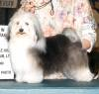 | AM CAN INTL MEX CHStarkette Pride of WincroftROMX | AM CHVoila Prime TimeROM | SUCHInvibe's Whiskey Pete's In Nevada
 |  |  |  | CHA Maiden Effort's Wish Me Luck
 |  |  | CHStarkette Cookies And CreamROM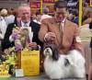 | AM CHKatrina's Charmer Of ManfredROMX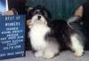
 |  |  |  | HCA CHStarkette Cabbage Patch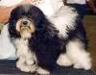
 |  | CHAmor Tamaran Pajama Party | CHPayasa Histyle Cash N' Dreams | AM CAN INTL MEX CHStarkette Pride of WincroftROMX
 |  |  |  | CHLeonardos Payasita YoYoRN
 |  |  | CH.Amor That Girl | CHLos Companero's V Havaluv
 |  |  |  | CHTapscott's Isadorable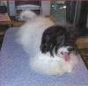
 | CHTigerlily Some Like It Hot | CHLos Perritos Shelly's Dakota | CHLos Perritos Scamp At Salem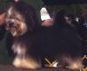 | CHLos Perritos LuigiROM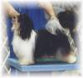
 |  |  |  | US CHLos Perritos Covered In FurROM
 |  |  | US CHBorgia's Evita Of Romanijo's JoyROMX | A Maiden Effort's Jazz-Up
 |  |  |  | NLCHA Maiden Effort's Ice Sugar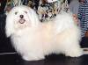
 |  | CHAmor's Calico Buttons | CHTapscott's Twist N Shout D'Amor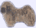 | AKC CHYes Giorio Vom SalzetalROMX
 |  |  |  | CHBonneterre Domino D'TapscottROM
 |  |  | CHAmor's That Girl | CHLos Companero's V Havaluv
 |  |  |  | CHTapscott's Isadorable
GCH UKC BISBeseme's Any Dream Will Do | CHLos Feliz Splash Of Mollimar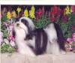 | CHLos Perritos Wee PantaloonsROMX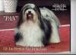 | CHLos Perritos LuigiROM | AM CHKatrina's Charmer Of ManfredROMX
 |  |  |  | HCA, CKC, ARBA, RARITY, DFUSA, INT IABKCA CHTi-Ara's Patty CakeROM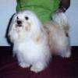
 |  |  | US CHBorgia's Evita Of Romanijo's JoyROMX | A Maiden Effort's Jazz-Up
 |  |  |  | NLCHA Maiden Effort's Ice Sugar
 |  | CHKolmar's MS QT PI Of Los Feliz | AM. CAN. CH.Voila Clean SweepROM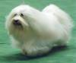 | INTUCH NORDUCHVoila Wow That's ItSV-99,NORDV-99,FINV-00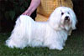
 |  |  |  | Voila Leading Lady
 |  |  | CHKolmar's La Nina Del Milenio | AM CAN INTL MEX CHStarkette Pride of WincroftROMX
 |  |  |  | CHKolmar's Starkette Las Palma
 | GCHBeseme's An Affair To Remember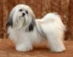 | CHShelley's Rickie Ricardo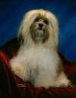 | CHAlderon's Shelley's Jamoacha | CHLos Perritos Make It Happen
 |  |  |  | Alderons Sparkling Chablis
 |  |  | Destiny's Shelley's Cookies N Creme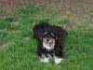 | Kimbriel's The Cisco Kid
 |  |  |  | Grillo De Destiny
 |  | CHLiveoak's Southern CharmRN ROM | CH.Yankee Joe Vom Salzetal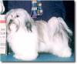 | VDHVKSetacane Martini Mit Zitrone
 |  |  |  | Unbelievable Uljana Vom Salzetal
 |  |  | CHEstrella's Razzle Dazzle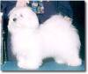 | HSDAA & AKC CHSalemi CharlyROMX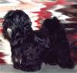
 |  |  |  | Kolmar's Rosie Mi Novia

